**Kocaeli University, Electronics and Telecommunication Engineering Department**

**Digital Communications Laboratory**

**Experiment 4:BASK Modulation and Demodulation- Simulink Lab Report (25.03.2024)**

|  |
| --- |
| Name-Surname-Number: Fatih Selim Erdeniz |
| Name-Surname-Number: Altar Hatipoğlu |
| Name-Surname-Number: Efe Eren Azman |

Block diagram of BASK modulation and demodulation is given in Figure 1. Bernoulli Binary generator generates 0 and 1 bits with equal probability. For bit = 0, the switch selects the carrier ${ i}_{0}$ with an amplitude of 1V and for bit=1 it switches to the carrier $i_{1}$ with an amplitude of 4V. The carrier frequency is $f_{c}=2$ Hz. The output signal spectrum can be analysed from the spectrum analyser. BASK demodulation can be realized synchronous and asynchronous ways. In synchronous mode, the same carrier signal ($f_{c} ,θ_{c}$) should be used at the receiver. In asynchronous demoulation, envelope detector is used.

**PART A: Modulation and Synchronous Demodulation**

All required blocks and parameters for the BASK experiment are given in Figures 1-3. Based on these,build the below diagram in Simulink and answer the following questions in detail.

**Figure 1.** BASK Modulator and Demodulator block diagram

**Required Simulink Blocks:**

1. Bernoulli Binary Generator

2. Sine Wave Generators

3.Switch

4. Constant

5. Relational operation

6. Product

7. Scope

8. Analog filter design

9. Zero-order hold

10. Spectrum analyser

After the received signal is multiplied by the carrier, it is applied as an input to the LPF.

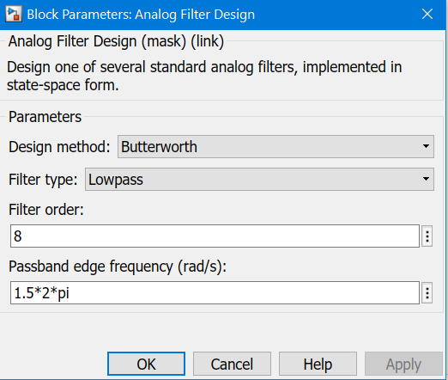

**Figure 2.** Parameters of the LPF

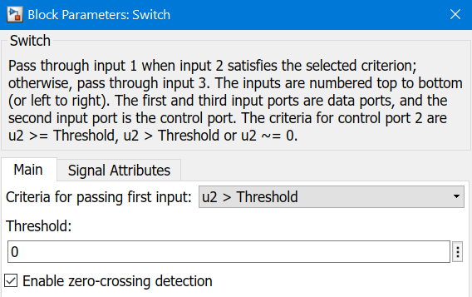

**Figure 3.** Parameters of the switch

**QUESTIONS**

**Q1.**What do you observe in the spectrum of BASK signal if the binary message amplitude is of alternate ones and zeros? Take a screenshot of the modulated signal from the scope over20secand explain what you observe.

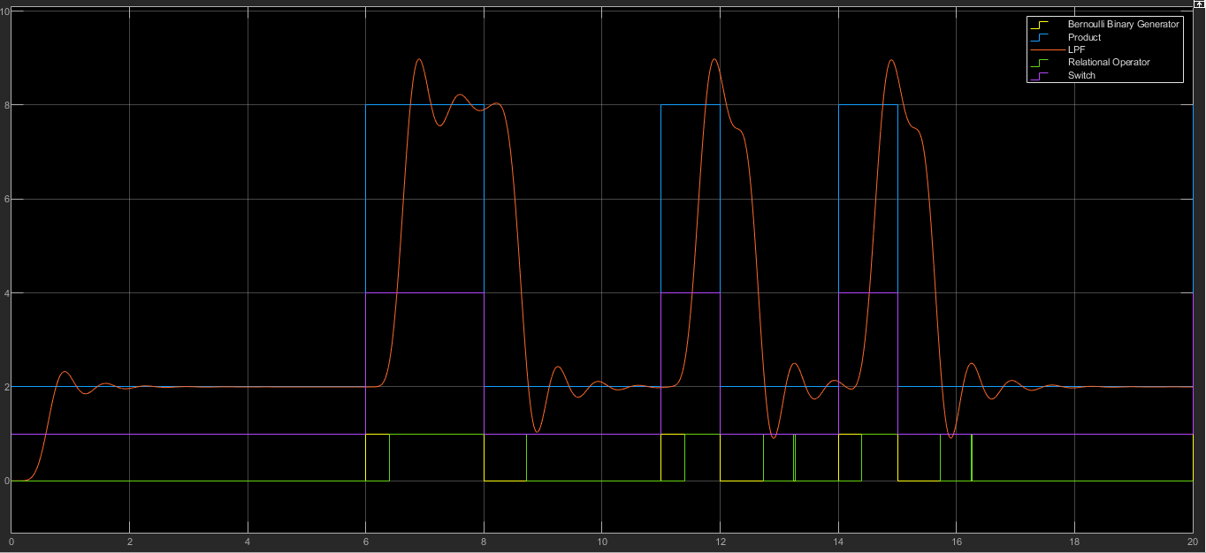

**Q2.** Repeat the experiment in the Q1 considering that the amplitude of the $i_{0}$ equals to zero. What do you observe in the spectrum of BASK signal in the scope over 50sec?

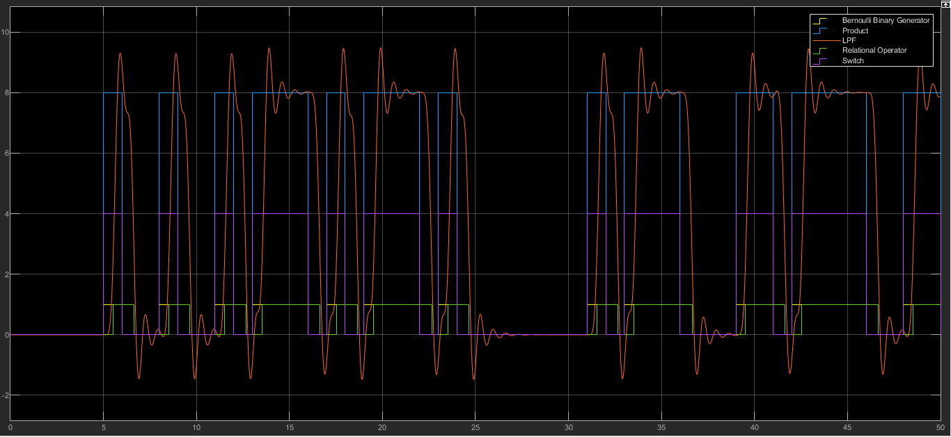

**Q3**.What is the bandwidth of the BASK modulated signal? Report the results from thespectrum analyser. Repeat the same experiment for $f_{c}=10$ Hz and compare the bandwidth of the BASK modulated signal with the result you obtained for $f_{c}=2$ Hz.

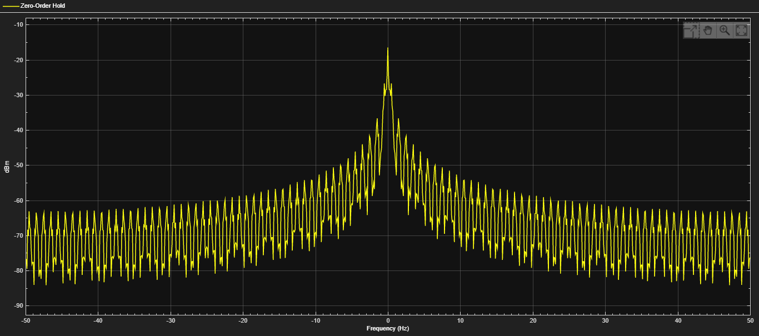

Şekil :fc=10Hz

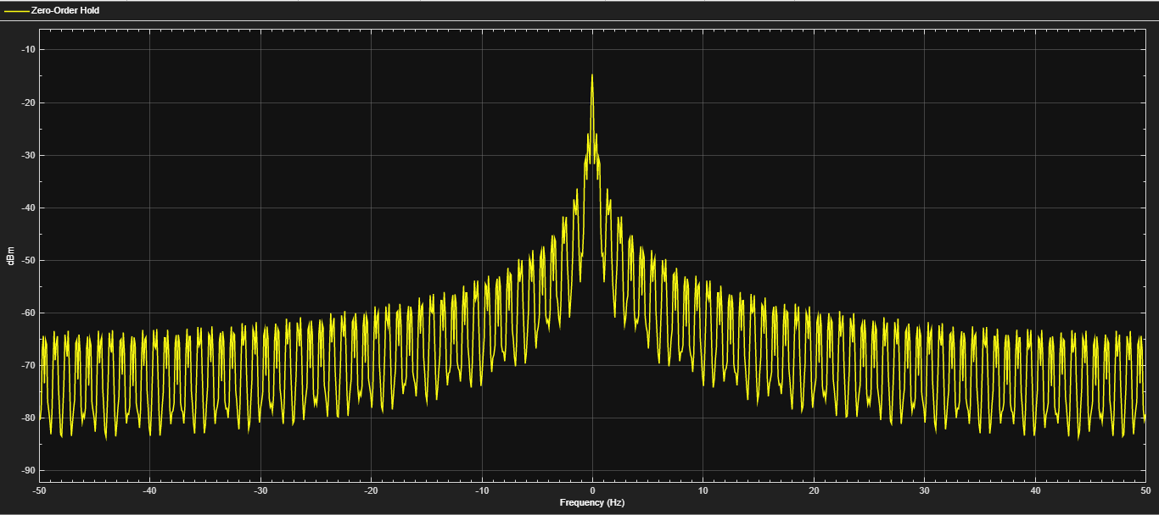

Şekil :fc=2Hz, RBW=97.6563Hz

**Q4**. What would be the optimum decision threshold at the demodulator? Theoretically calculate the value. Run the experiment for the optimum decision threshold value and compare the demodulated signal you observe in the scope with a decision threshold of 1.

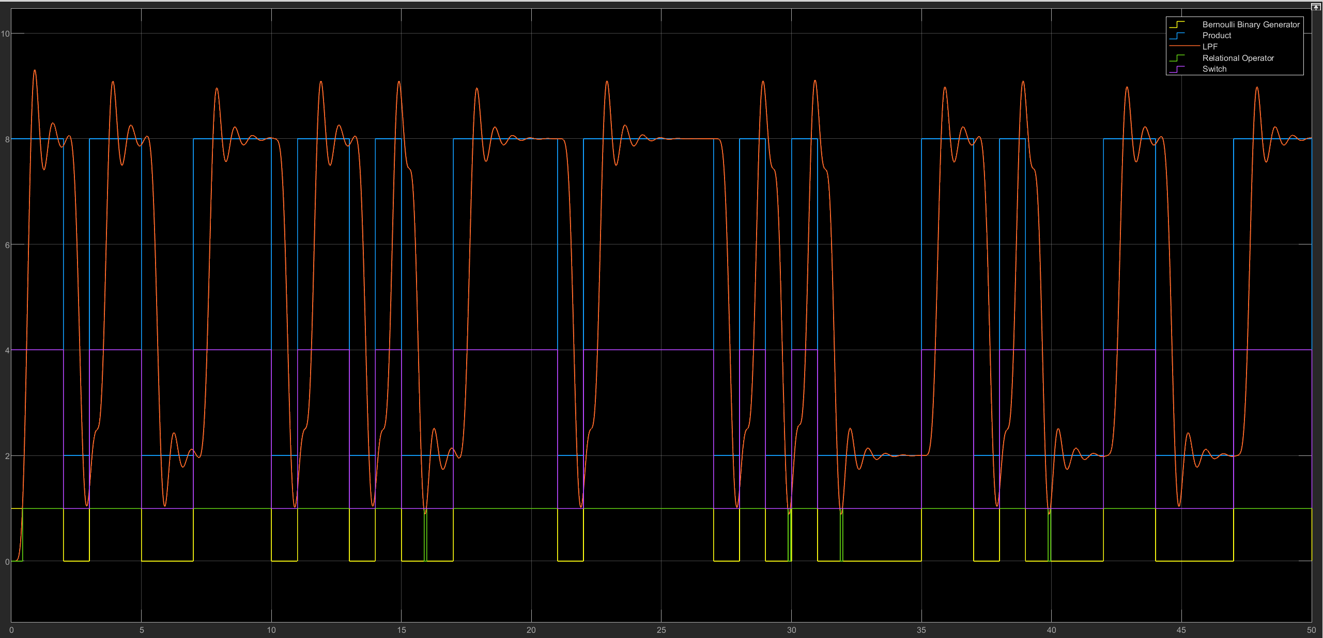

**Q5**. Set the phase of the carrier signal in the receiver as $π$/2. Did you obtain the same bit stream as input at the output?

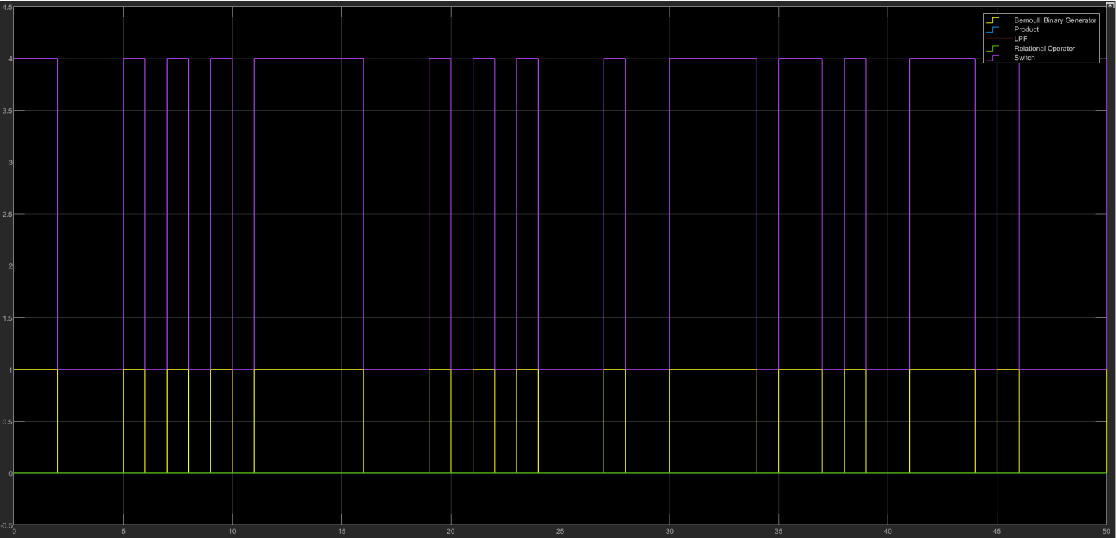

**PART B: Modulation and Asynchronous Demodulation**

**Q6.**Figure 4 present an envelope detector for BASK modulation signal. In Figure 1, you obtained BASK signal as an output of the switch. In Part B, build the below diagram and obtain the output bit sequence. Then, show the output sequence in the scope with the input bit sequence together. Add the screen-shot of the scope to your report. Required blocks and their parameters are given in Figure 5.

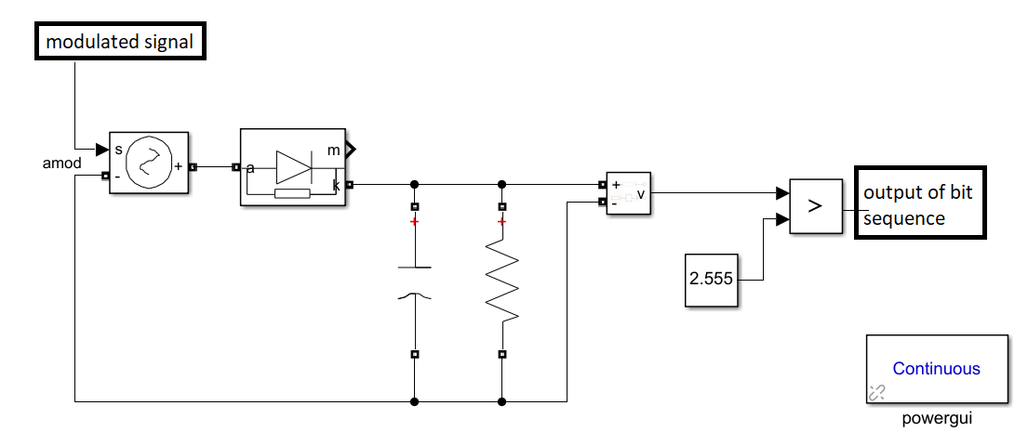

**Figure 4.** Envelope detector for asynchronous demodulation.

|  |  |  |
| --- | --- | --- |
| Required blocks and parameters:   * Controlled Voltage Source * Diode * Series RLC Branch * Voltage Measurement * Relation Operator   **Capacitance:**7µF  **Resistance:** 350kΩ |  |  |
| (a) | (b) | (c) |

**Figure 5.** (a) Required Blocks’ name and its parameters, (b) Parameters of Controlled Voltage Source, (c) Parameters of Diode.

**Q7.** Set the below parameters for resistor (R), capacity (C) components and threshold value. Fill the table. How the parameters are determined, explain.

|  |  |  |  |
| --- | --- | --- | --- |
| **R** | **C** | **Threshold** | **Observation: Did you obtain the same bit sequence at the output? (YES / NO, Why?)** |
| 600kΩ | 7 $μF$ | 2.555 |  |
| 350kΩ | 0.7 $μF$ | 2.555 |  |
| 350kΩ | 0.7 $μF$ | 0.5 |  |